South Saskatchewan Youth Orchestra Covid-19 Protocol

The Board of the SSYO desires to create a safe environment for young musicians to continue to enjoy orchestra while minimizing the risk of covid-19 transmission to musicians, staff, and families. The risk of Covid-19 transmission is evolving. While the board will monitor public health recommendations (Saskatchewan Performing Arts Guidelines) and adjust the rehearsal protocol as needed, risk of Covid-19 cannot be completely eliminated. This protocol is an initial version and revisions will be made as the covid-19 situation evolves and as we learn how to operate under this new format.
This is going to be a learning process as we work together to reopen. We ask that you be patient with us
and each other and help as much as possible, whether that be through volunteering time, suggestions or
just positive reassurance.

Throughout the 2020/2021 Season:
- Any musician that is unwell for any reason must not attend rehearsal. If any family members living in the same household are unwell the musician will not attend rehearsal.
- Parents or Guardians of musicians under 18 must sign a declaration form (see attached) indicating they and other household members are well prior to each rehearsal. Musicians over 18yrs and older must sign their own declaration. The declaration form will be signed and shown before entering Knox Metropolitan Church for each rehearsal. If the musician does not have a signed declaration form they will not be permitted entry.
- If a musician tests positive for covid-19, that group will suspend rehearsals for at least 2 weeks.
- In order to limit the gathering size to less than 30 people the orchestra will be split into 2 groups, which will rehearse separately.
  - Group 1 – Strings - violin, viola, cello, bass Mondays 7:30-9:00
  - Group 2 – Winds - woodwind, brass, percussion, and other instruments Thursdays 7:30-9:00
- Musicians must bring only essential personal items, their instrument, stand and sheet music to rehearsal. A personal drink bottle is permitted. Instrument case and any other belongings will remain in their chair space throughout rehearsal.
- Masks will be worn at all times except when required for performing (e.g. wind instruments). Musicians will bring their own masks; a few will be available if any musicians forget to bring one.
- Non-musicians will not be permitted to enter Knox unless they are involved in assisting with the set-up or storage of chairs or verification of declaration forms.
- Wind instruments will be used with a bell cover if appropriate. Refer to your music lesson instructor for guidance.

Rehearsal set-up and take-down
One musician family will be designated each rehearsal to set-up and take-down all chairs and hand sanitizing stations. Set-up will be such that it ensures the 2m spacing requirement is observed with greater spacing for wind instruments. This family should arrive 15 minutes prior to rehearsal.

Arrival
Musicians will arrive via the Victoria Street entrance wearing a mask. Two adults will verify each musician’s Covid-19 Declaration Form. Any musician that responds yes to any of the declaration questions will not be allowed to attend the rehearsal. The musician will then proceed directly to their chair/stand and set-up their instrument. They will then proceed to a hand sanitizing station located in several places around the rehearsal hall.

Rehearsal
Rehearsal will be 90 minutes. Musicians and musical director will continue to wear a mask throughout rehearsal except when playing a wind instrument. Musicians will bring their own stands to minimize sanitization requirements.

Bell covers will be required for suitable wind instruments. Consult with your music teacher regarding covers. Cleaning of excess moisture that accumulates in brass or other instruments will be kept to a minimum and done away from other musicians. Don’t drain them onto the floor.

Departure
Musicians will wait in their chair space until notified via text that their ride is ready to pick them up. Musicians will not be allowed to wait for rides in the lobby. Chairs will be sanitized either with a spray or wipes before being returned to storage.

We remind everyone that it is very important for musicians to adhere to the guidelines and stay away if you or anyone in your household are unwell. People with compromised immune systems need to assess their personal situation before deciding to attend.

South Saskatchewan Youth Orchestra Board of Directors

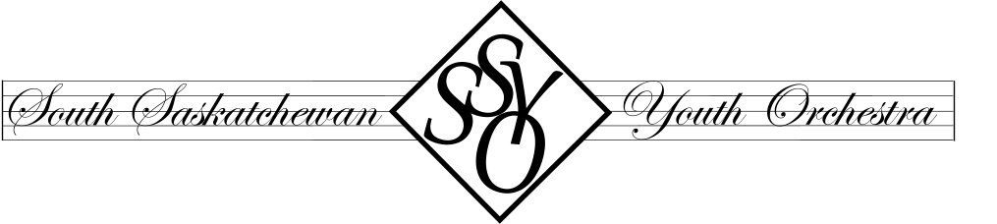
South Saskatchewan Youth Orchestra COVID-19 Declaration Form
Musician Name __________________________________________________
Contact Details: Cell Phone/Home Number ____________________________
Email Address ___________________________________________________

Please answer the following questions and sign below prior to every rehearsal you attend.
1 – Are you or anyone you share a residence with experiencing any Covid-19 symptoms?
(coughing, fever, shortness of breath)
Yes ____ No ____
2 – Have you travelled outside Canada in the past 14 days?
Yes ____ No ____
3 – Have you or anyone you share a residence with been in contact with any person demonstrating covid-19 symptoms in the past 14 days?
Yes ____ No ____
If you answer yes to any of these questions you are not to attend rehearsal at this time.

Declaration:
I declare that the responses above to be true and accurate. (Musicians under 18 will require a parent/guardian signature)

Date Name Signature

