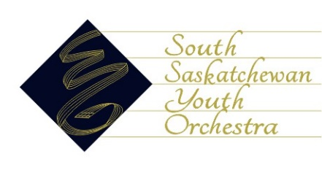
South Saskatchewan Youth Orchestra
Annual General Meeting
13 September, 2021
Knox Metropolitan Church room 105
7:00 PM
PRESENT: Board Members: Al Denike, Rudy Sternadal, Doug Charko, Ian Walker, Susan Nurse, Ademola Osokoya, Brad Zakreski, Renee Mahajan, Allison Sweet, Elaine Thompson, Fay Lu
Others:
ABSENT:
- Call to Order & Welcome

- Welcome and Introductions – Parents of musicians
- Approval of Agenda, with amendments to order, by consensus.

- Music Director – Al Denike.
- Covid-19 and Vaccine Protocol – Doug Charko

- Membership – Susan Nurse

- Treasurer – Ademola Osokoya. Budget

- Sponsorship – Brad Zakreski

- Major Events & Volunteers – Floor Manager

- Election of board positions – As a non-profit, there is a need for the following positions to be filled: Nominations and elections as follows:

President

Membership

Communications

- Adjournment:

